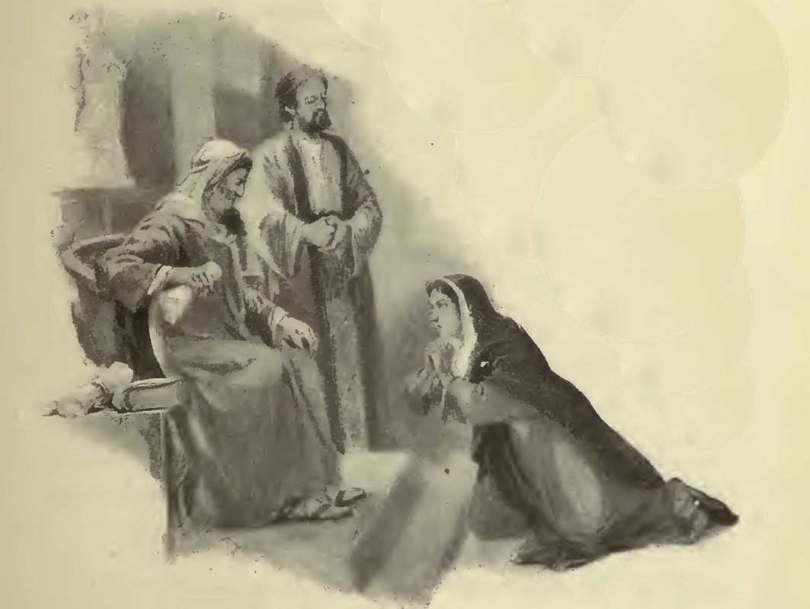
The Congregational
Church of Salisbury

United Church of Christ

20 October 2019 • 10:00am
Nineteenth Sunday
Chiming of the Hour
Welcome
Prelude “Come, O Creator, Spirit Blest” Flor Peeters
Announcements | Joys and Concerns | Silent Prayer
Introit “Come into His Presence with Thanksgiving” Johnny Yarrington
Call to Worship
One: We have gathered in God’s holy presence, who etches grace on our hearts.
Many: This is the company with whom God will transform us into disciples.
We glorify God, who yearns for justice —
not just for a favored few, but for the lost and left out and least of our world.
This is the day when God will write compassion on our souls.
We give thanks to God for unceasing grace; we remember God’s persistence
in saving us with the seeming powerlessness of love.
This is the moment when God will again breathe the Word of Life
into our lives: Alleluia!
Hymn #688 “Spirit of God, Descend Upon My Heart” Morecambe
verses 1, 2, 4, 5
Call to Reconciliation
One: Seeking to follow Jesus, we often wander down the wrong roads. Impatient with God’s schedule, we rush off to do things our way. Let us confess our foolishness, that we might receive God’s hope for our lives.
Unison Prayer of Confession
Your words are given to us, Author of Life, so we might be reformed, but we are intent on changing others. Your words are offered to us so we might be transformed, but we are focused on conforming to our culture. Your words are spoken to lead us into new life, but we hold our old ways tight to our chests.
Forgive us, God of Wonder. Do not remember our sins, but continue to touch us with your steadfast mercy. Show us how to be persistent in living out our faith, even as you were so tenacious in offering us your grace and life in Jesus Christ, our Master and Savior.
(We pray in silence)
Assurance of Pardon
One: Jesus reminds us that we are to be resolute in our lives of faithfulness and service. The good news is that God is steadfast in filling us with love and grace.
All: We are forgiven people. May we live as sisters and brothers in Christ, God’s children in word and deed, in hope and joy. Thanks be to God. Amen.
Gloria Greatorex
Glory to the Creator, and to the Christ, and to the Holy Ghost;
as it was in the beginning, is now, and ever shall be,
world without end. Amen; Amen.

We Proclaim the Gospel in Word
A Thought for Young Minds
The Lord’s Prayer (debts)
Hymn #175 “Seek Ye First” Lafferty
Children (PreK–5th grade) attending Church School may leave as we sing the hymn.
Responsive Psalter: Psalm 121
One: I lift up my eyes to the hills.
Many: Where will my help come from?
My help comes from the Holy One,
The Maker of heaven and earth.
God will not let your foot slip;
The God who keeps watch over you will not slumber.
The God who keeps watch over the people will neither slumber nor sleep.
The Eternal One is your keeper;
The Most High is your protection,
Close by, at your right hand.
The sun shall not strike you by day,
Nor the moon disturb you by night.
The Almighty will keep you from all harm;
God will keep safe your life.
The Holy One will keep watch over
your going out and your coming in,
Now and forevermore.
Scripture Reading 2 Timothy 3:14–4:5 New Testament, p. 260
Gospel Reading: Luke 18:1-8 New Testament, p.99
Sermon “Convicted of Christianity” John A. Nelson

We Respond in Prayer and Faith
Pastoral Prayer | Silent Prayer
Offertory
One: We worship God — whose grace is more persistent than the widow seeking justice, the One whose justice is more grace-filled than any human judging. We worship the God who simply pours out life, and lovingly invites us to live within the realm of mercy and wonder. Even in our generosity, we worship: let the moment of giving our tithes and offerings be a joy and delight!
All: All: Let us gather our gifts with grateful praise,
and offer them to God’s purposes.
Receiving Our Offerings
Musical Offering “Take It to the Lord in Prayer” Joel Raney
Doxology Old 100th
Praise God from whom all blessings flow;
Praise Christ, all people here below;
Praise Holy Spirit ever more;
One God of grace, whom we adore! Amen.
Unison Prayer of Dedication
Like your words, O God, the tangible gifts with which we are blessed are not to be hoarded or hidden away for rainy days. Rather, we offer them so they might bring healing, hope, grace, and peace to your children, near and far. In Jesus’ name, we pray: Amen.
Hymn #450 “Be Thou My Vision” Slane
Benediction and Sung Amen (Hymnal, #600)
Postlude “Allegro Maestoso” Flor Peeters


Please Recycle this Bulletin!
The Congregational Church of Salisbury
United Church of Christ
Whoever you are, wherever you are on life’s journey: you are welcome here.
30 Main Street | P.O. Box 392 | Salisbury, CT 06068 • 860-435-2442
info@salisburycongregationalchurch.org
www.salisburycongregationalchurch.org
Office Hours: 9am – 2pm, Monday-Friday

